G VENKATA SRIDHAR  gvsridhar.devops@gmail.com
+91-9739964629

DOCKER
What is Docker?
- Docker is the world’s leading software container platform.
- Docker makes the process of application deployment very easy and efficient and resolves many issues related to deploying applications.
- Docker is a tool designed to make it easier to deploy and run applications by using containers.
- Docker gives you a standard way of packaging your application with all its dependencies in a container.
- Containers allow a developer to package up an application with all of the parts it needs, such as libraries and other dependencies, and ship it all out as one package.

- Understand Docker with analogy of the Shipping industry.
- How a real world problem was resolved using containers.

How Docker Works?
Understand a general workflow of docker
Difference between virtualization and containerization
Understand docker client server architecture

Understand:
Docker file
Docker Compose file
Docker images
Docker Containers
Docker Hub / Docker Registry
Docker client
Docker server / Docker daemon
Docker engine

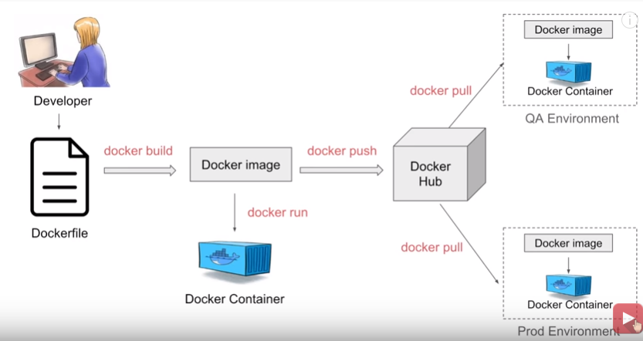
Benefits of using Docker
- Build app only once
- No worries that the application will not perform the same way it did on testing env
- Portability
- Version Control
- Isolation
- Productivity
- Docker simplifies DevOps

How to install Docker on Linux?
- Agenda:
- Prerequisites
- Connect to Linux
- Install Docker
- Start Docker
- Stop Docker
- Uninstall Docker

Prerequisites
- OS should be 64 bit
- Linux kernel version 3.10 or greater
- Command to check : uname -r

Step 1: Connect to Linux system

Step 2: INSTALL Docker
  - sudo yum -y update
  - sudo yum install -y docker
  - docker
  - docker --version

Step 3: START Docker
  - sudo service docker start
  - sudo usermod -a -G docker "user"
  - docker info
  - docker run hello-world: To run hello-world image
  - docker images: To get list of images present locally
  - docker ps: To get list of running containers
  - docker ps -a . : To get list of all containers

Step 4: STOP Docker
- sudo service docker stop
- uninstall DOCKER
- sudo yum remove docker

HELPFUL TIPS
You can visit - https://get.docker.com/
To install docker from binaries - https://docs.docker.com/install/linux/docker-ce/binaries/
Installation steps for amazon ec2 -
https://docs.aws.amazon.com/AmazonECS/latest/developerguide/docker-basics.html

References:
Linux free instance –
https://aws.amazon.com/free/?all-free-tier.sort-by=item.additionalFields.SortRank&all-free-tier.sort-order=asc

Docker Manuals - https://docs.docker.com/manuals/
FREE Courses - https://automationstepbystep.com/online-courses/
Docker Toolbox GitHub - https://github.com/docker/toolbox/releases/tag/v18.09.3
Watch Docker Playlist - https://www.youtube.com/playlist?list=PLhW3qG5bs-L99pQsZ74f-LC-tOEsBp2rK

How to Create a Boot2Docker virtual machine locally on your Windows machine using Hyper-V - https://docs.docker.com/machine/drivers/hyper-v/

How to install Docker on Windows Step by Step?
- Agenda:
- Prerequisites
- Install Docker
- Troubleshooting tips
- Validate installation
- Uninstall Docker

Prerequisites
- OS should be 64 bit
- Windows 7 or higher

Step 1: Install Docker
https://docs.docker.com/toolbox/toolbox_install_windows/
https://docs.docker.com/docker-for-windows/install/

Step 2: Troubleshooting (if any issue occurs)
Convenient way to enable/disable Hyper-V
https://superuser.com/questions/540055/convenient-way-to-enable-disable-hyper-v-in-windows-8

Installing Docker Toolbox on Windows with Hyper-V Installed
https://jayvilalta.com/blog/2016/04/28/installing-docker-toolbox-on-windows-with-hyper-v-installed/

Step 3: Validate INSTALLATION, run some docker commands
  - docker
  - docker --version
  - docker run "image name"

Step 4: Uninstall Docker
- sudo service docker stop
- uninstall DOCKER
- sudo yum remove docker

USEFUL INFORMATION - If you install the Docker Toolbox on a Windows machine, the installer automatically installs Oracle VirtualBox to run the Docker virtual machine.

USEFUL LINKS
https://stackoverflow.com/questions/36885985/cannot-start-docker-after-installation-on-windows
https://docs.docker.com/toolbox/faqs/troubleshoot/

How to install Docker on MacOS?
Prerequisites
- Docker - Mac OS Yosemite 10.10.3 or Above
- Docker Toolbox - mac OS 10.8 “Mountain Lion” or Newer

Step 1: Install Docker
Step 2: Validate INSTALLATION, run some docker commands
Step 3: Uninstall Docker

References:
https://www.docker.com/
https://www.docker.com/docker-mac
https://hub.docker.com/editions/community/docker-ce-desktop-mac
https://www.docker.com/products/docker-desktop
https://docs.docker.com/toolbox/overview/
https://docs.docker.com/toolbox/toolbox_install_mac/

Docker Basic Commands Step by Step for Beginners
Basic | Containers | Images | System
- docker version  - docker -v  - docker info  - docker --help  - docker login | - docker ps  - docker run  - docker start  - docker stop | - docker images  - docker pull  - docker rmi | - docker stats  - docker system df  - docker system prune

References:
https://hub.docker.com/
https://docs.docker.com/engine/reference/commandline/ps/
https://automationstepbystep.com/

What are Docker Images?
- Docker Images are templates used to create Docker containers.
- Container is a running instance of image.

Where are Images Stored?
- Registries (e.g. Docker Hub) & Can be stored Locally or Remote.

Docker Image Basic Commands
- docker images --help  - docker pull image  - docker images  - docker images -q  - docker images –f “dangling=false”  - docker images –f “dangling=false” -q | - docker run image  - docker rmi image  - docker rmi –f image  - docker inspect  - docker history imageName
References:
https://hub.docker.com/_/ubuntu/
https://docs.docker.com/engine/reference/commandline/images/

What are Containers?
- Containers are running instances of Docker Images

Docker Container Basic Commands
- docker ps  - docker run ImageName  - docker start ContainerName/ContainerID  - docker stop ContainerName/ContainerID  - docker pause ContainerName/ContainerID  - docker unpause ContainerName/ContainerID | - docker top ContainerName/ContainerID  - docker stats ContainerName/ContainerID  - docker attach ContainerName/ContainerID  - docker kill ContainerName/ContainerID  - docker rm ContainerName/ContainerID  - docker history ContainerName/ContainerID

References:
https://www.google.co.in/search?rlz=1C5CHFA_enIN734IN734&biw=1280&bih=703&tbm=isch&q=docker+containers&chips=q:docker+containers,g_5:architecture+docker&sa=X&ved=0ahUKEwiRhIOgkYXcAhVEqo8KHYjABTcQ4lYIMCgA#imgrc=AfGnqueGte31MM:

https://docs.docker.com/engine/reference/commandline/container/#child-commands

Note: A container image is a lightweight, stand-alone, executable package of a piece of software that includes everything needed to run it: code, runtime, system tools, system libraries, settings.

Features of Containers:
- Are lightweight
- Fewer resources are used
- Booting of containers is very fast
- Can start, stop, kill, and remove containers easily and quickly
- Operating System resources can be shared within Docker
- Containers run on same machine sharing same Operating system Kernel, this makes it faster
- You can use the command docker container create to create a container in stopped state

Jenkins Playlist - https://www.youtube.com/playlist?list=PLhW3qG5bs-L_ZCOA4zNPSoGbnVQ-rp_dG

How to start Jenkins on Docker Container
- Start and Stop Jenkins Container

How to set Jenkins home on Docker Volume and Host Machine
- docker pull jenkins
- docker run -p 8080:8080 -p 50000:50000 jenkins
- docker run --name MyJenkins -p 8080:8080 -p 50000:50000 -v /Users/raghav/Desktop/Jenkins_Home:/var/jenkins_home jenkins
- docker run --name MyJenkins2 -p 9090:8080 -p 50000:50000 -v /Users/raghav/Desktop/Jenkins_Home:/var/jenkins_home jenkins
- docker volume create myjenkins
- docker volume ls
- docker volume inspect myjenkins
- docker run --name MyJenkins3 -p 9090:8080 -p 50000:50000 -v myjenkins:/var/jenkins_home jenkins
- docker inspect MyJenkins3

- In case you face issues like installing plugins on this Jenkins, can setup jenkins with this command:
- $ docker run -u root --rm -p 8080:8080 -v /srv/jenkins-data:/var/jenkins_home -v /var/run/docker.sock:/var/run/docker.sock --name jenkins jenkinsci/blueocean

References
https://hub.docker.com/

USEFUL INFORMATION - Installed docker client binaries in the jenkins image, added the jenkins user to the docker group and provided full permission to the docker.socket process.

What is Dockerfile?
- A text file with instructions to build image

Automation of Docker Image Creation
- FROM
- RUN
- CMD

Step 1: Create a file named Dockerfile
Step 2: Add instructions in Dockerfile
Step 3: Build dockerfile to create image
Step 4: Run image to create container

Dockerfile Basic Commands
- docker build
- docker build -t ImageName: Tag directoryof Dcokerfile
- docker run image

References:
https://github.com/wsargent/docker-cheat-sheet#dockerfile
https://docs.docker.com/engine/reference/builder/#environment-replacement
https://www.google.co.in/search?q=dockerfile&rlz=1C5CHFA_enIN734IN734&source=lnms&tbm=isch&sa=X&ved=0ahUKEwicqqOe_oTcAhWLbysKHX_6B5sQ_AUICigB&biw=1280&bih=703#imgrc=zY4gTeVpM446JM:

What | Why - Docker Compose
- Tool for defining & running multi-container docker applications
- Use YAML files to configure application services (docker-compose.yml)
- Can start all services with a single command: docker compose up
- Can stop all services with a single command: docker compose down
- Can scale up selected services when required

How to Install?
Step 1: Install docker compose (already installed on windows and mac with docker)
- docker-compose -v

Two Ways to install Docker Compose
- https://github.com/docker/compose/releases
- Using PIP - pip install -U docker-compose

Step 2: Create docker compose file at any location on your system
- docker-compose.yml

Step 3: Check the validity of file by command
- docker-compose config

Step 4: Run docker-compose.yml file by command
- docker-compose up -d

Step 5: Bring down application by command
- docker-compose down

How to scale services
- docker-compose up -d --scale database=4

References:
https://hub.docker.com/
https://github.com/docker/compose/releases
https://docs.docker.com/compose/compose-file/

https://www.google.co.in/search?q=microservices+example&rlz=1C5CHFA_enIN734IN734&source=lnms&tbm=isch&sa=X&ved=0ahUKEwjE3LPQqYfcAhXGpY8KHQHmB4gQ_AUICigB#imgrc=4466IjbSng_wcM:

What are Volumes?
- Volumes are the preferred mechanism for persisting data generated by and used by Docker containers

How to create / list / delete volumes Basic Commands
- docker volume //get information
- docker volume create
- docker volume ls
- docker volume inspect
- docker volume rm
- docker volume prune

Use of Volumes
- Decoupling container from storage
- Share volume (storage/data) among different containers
- Attach volume to container
- On deleting container volume does not delete

How to create / list / delete volumes Basic Commands
- docker run --name MyJenkins1 -v myvol1:/var/jenkins_home -p 8080:8080 -p 50000:50000 jenkins
- docker run --name MyJenkins2 -v myvol1:/var/jenkins_home -p 9090:8080 -p 60000:50000 jenkins
- docker run --name MyJenkins3 -v /Users/raghav/Desktop/Jenkins_Home:/var/jenkins_home -p 9191:8080 -p 40000:50000 jenkins

References
https://hub.docker.com/_/jenkins/
https://docs.docker.com/storage/volumes/

NOTE: By default, all files created inside a container are stored on a writable container layer.
The data does not persist when that container is no longer running
A container’s writable layer is tightly coupled to the host machine where the container is running.
You cannot easily move the data somewhere else.
Docker has two options for containers to store files in the host machine. So that the files are persisted even after the container stops

Difference between VOLUMES & BIND MOUNTS
Volumes | Bind Mounts
Volumes are stored in a part of the host filesystem, which is managed by Docker. | Bind mounts may be stored anywhere on the host system.
Non-Docker processes should not modify this part of the filesystem. | Non-Docker processes on the Docker host or a Docker container can modify them at any time.
Volumes are managed by Docker and are isolated from the core functionality of the host machine.  Volumes are the best way to persist data in Docker. | In Bind Mounts, the file or directory is referenced by its full path on the host machine.
- A given volume can be mounted into multiple containers simultaneously.
- When no running container is using a volume, the volume is still available to Docker and is not removed automatically. You can remove unused volumes using docker volume prune.
- When you mount a volume, it may be named or anonymous.
- Anonymous volumes are not given an explicit name when they are first mounted into a container
- Volumes also support the use of volume drivers, which allow you to store your data on remote hosts or cloud providers, among other possibilities.

What is Docker Swarm?
- A swarm is a group of machines that are running Docker and joined into a cluster.
- Docker Swarm is a tool for Container Orchestration.

Let’s take an example
You have 100 containers
You need to do
- Health check on every container
- Ensure all containers are up on every system
- Scaling the containers up or down depending on the load
- Adding updates/changes to all the containers

Orchestration - Managing and Controlling multiple docker containers as a single service
- Tools available - Docker Swarm, Kubernetes, Apache Mesos. Etc.

Pre-requisites
- Docker 1.13 or higher
- Docker Machine (pre installed for Docker for Windows and Docker for Mac)
https://docs.docker.com/machine/install-machine/#installing-machine-directly
https://docs.docker.com/get-started/swarm-deploy/

Step 1: Create Docker machines (to act as nodes for Docker Swarm) Create one machine as manager and others as workers.
- docker-machine create --driver Hyper-V manager1
- docker-machine create --driver virtualbox manager1
- docker-machine:Error with pre-create check: “exit status 126”
https://stackoverflow.com/questions/38696164/docker-machineerror-with-pre-create-check-exit-status-126

- brew cask install VirtualBox
- Create one manager machine and other worker machines

Step 2: Check machine created successfully
- docker-machine ls
- docker-machine ip manager1

Step 3: SSH (connect) to docker machine
- docker-machine ssh manager1

Step 4: Initialize Docker Swarm
- docker swarm init --advertise-addr MANAGER_IP
- docker node ls
(This command will work only in swarm manager and not in worker)

Step 5: Join workers in the swarm. Get command for joining as worker, in manager node run command.
- docker swarm join-token worker (This will give command to join swarm as worker)
- docker swarm join-token manager (This will give command to join swarm as manager)
- SSH into worker node (machine) and run command to join swarm as worker.
- In Manager Run command - docker node ls to verify worker is registered and is ready
- Do this for all worker machines

Step 6: On manager run standard docker commands
- docker info (Check the swarm section, no of manager, nodes etc.)
- docker swarm (Now check docker swarm command options)

Step 7: Run containers on Docker Swarm
- docker service create --replicas 3 -p 80:80 --name serviceName nginx
- Check the status: docker service ls
- docker service ps serviceName
- Check the service running on all nodes
- Check on the browser by giving ip for all nodes

Step 8: Scale service up and down, on manager node
- docker service scale serviceName=2

- Inspecting Nodes (this command can run only on manager node)
- docker node inspect nodename
- docker node inspect self
- docker node inspect worker1

Step 9: Shutdown node
- docker node update --availability drain worker1

Step 10: Update service
- docker service update --image imagename:version web
- docker service update --image nginx:1.14.0 serviceName

Step 11: Remove service
- docker service rm serviceName
- docker swarm leave (To leave the swarm)
- docker-machine stop machineName (To stop the machine)
- docker-machine rm machineName (To remove the machine)

REFERENCES:
https://docs.docker.com/get-started/swarm-deploy/
https://rominirani.com/docker-swarm-tutorial-b67470cf8872

FAQs & Helpful Tips:
- A swarm is a group of machines that are running Docker and joined into a cluster
- A cluster is managed by swarm manager
- The machines in a swarm can be physical or virtual. After joining a swarm, they are referred to as nodes
- Swarm managers are the only machines in a swarm that can execute your commands, or authorize other machines to join the swarm as workers
- Workers are just there to provide capacity and do not have the authority to tell any other machine what it can and cannot do.
- You can have a node join as a worker or as a manager. At any point in time, there is only one LEADER and the other manager nodes will be as backup in case the current LEADER opts out.

References
https://www.google.co.in/search?q=how+docker+works&rlz=1C5CHFA_enIN734IN734&source=lnms&tbm=isch&sa=X&ved=0ahUKEwijsqXlhorcAhVKLY8KHYw4BQEQ_AUICygC&biw=1280&bih=703#imgrc=ozZsDDX9ZCaf4M:

https://www.google.co.in/search?q=docker+vs+vm&rlz=1C5CHFA_enIN734IN734&source=lnms&tbm=isch&sa=X&ved=0ahUKEwiSl5vxhorcAhUH6Y8KHfNmCYoQ_AUICigB&biw=1280&bih=703

https://www.google.co.in/search?q=docker+architecture&rlz=1C5CHFA_enIN734IN734&source=lnms&tbm=isch&sa=X&ved=0ahUKEwixxvyWhIrcAhUKtY8KHaElD4EQ_AUICigB&biw=1280&bih=703#imgrc=ozZsDDX9ZCaf4M:

Docker Interview Questions
What is Docker?
- Docker is a Tool designed to make it easier to deploy and run applications by using containers.
- Containers allow a developer to package up an application with all of the parts it needs, such as libraries and other dependencies and ship it all out as one package.
- Build App only once – An Application inside a container can run on any system that has Docker installed. Therefore, there is no need to build and configure app multiple times on different platforms.

How Docker works?
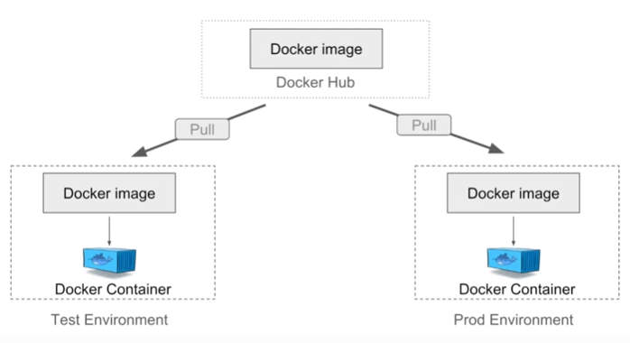

Difference between Virtualization & Containerization?

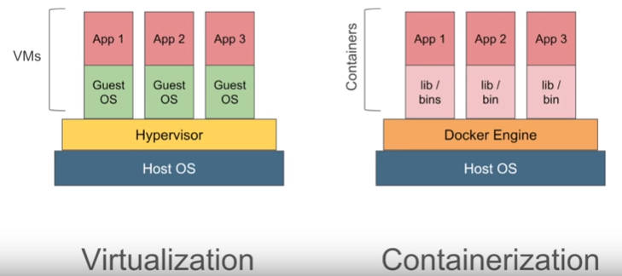

Explain Docker Architecture?
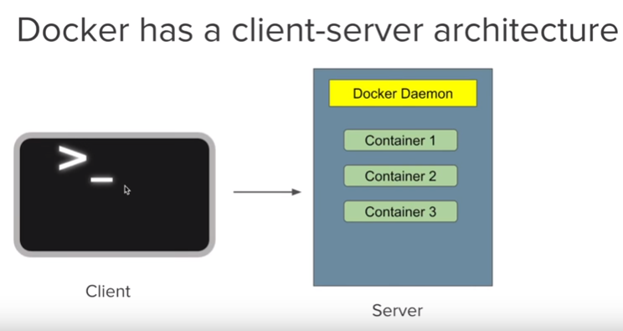

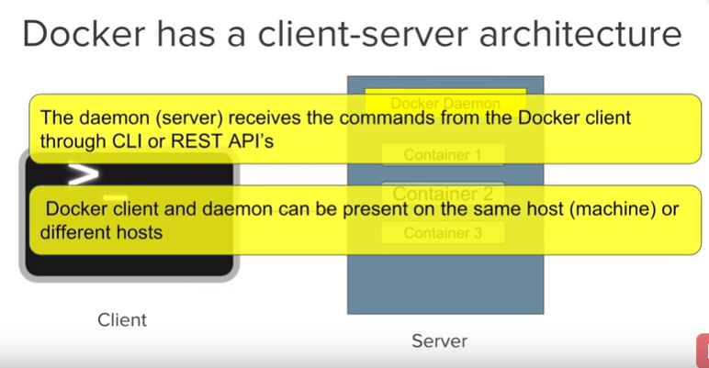

Advantages of using Docker?
- Build App only once – An Application inside a container can run on any system that has Docker installed. Therefore, there is no need to build and configure app multiple times on different platforms.
- More sleep and less worry – With docker to test your application inside a container and ship it inside a container. This means the environment in which you test is identical to the one on which the app will run in production.
- Portability – Docker Containers can run on any platform. It can run on your Local System, Amazon EC2, Google Cloud Platform, Rackspace Server, Virtual Box etc. A container running on AWS can easily be ported to Virtual Box.
- Version Control – Like GIT, Docker has in-build Version Control. Docker containers will work just like GIT repositories, allowing you to commit changes to your Docker images and version control them.
- Isolation – With docker, every application works in isolation in its own container and does not interferes with other applications running on the same system. So multiple containers can run on same system without interference. For removal also you can simply delete the container and it will not leave behind any files or traces on the system.
- Productivity – Docker allows faster and more efficient deployments without worrying about running your app on different platforms.

What are Docker Images?
- Docker Images are templates used to create Docker Containers. Container is a running instance of image.
- Images are stored Locally or Remote (Registries Ex: Docker Hub)
- Docker Image Commands are,
- docker images
- docker pull
- docker push
- docker run
- docker rmi
- docker inspect
- docker history
- Docker can build Images automatically by reading the instructions from a DockerFile.
- Containers are running instances of Docker Images.
- A single image can be used to create multiple containers.

What are Docker Containers?
- Containers are running instances of Docker Images.
- Docker Container Commands are,
- docker ps
- docker run
- docker start
- docker pause
- docker unpause
- docker attach
- docker kill
- docker rm
- Docker Container Features are,
- Lightweight
- Less resources are used
- Booting of containers are very fast
- Can start, stop, kill, and remove containers easily and quickly
- Operating System Resources can be shared within Docker

What is DockerFile?
- A text file with instructions to build image.
- Step 1: Create a file named Dockerfile
- Step 2: Add instructions in Dockerfile
- Step 3: Build Dockerfile to create image
- Step 4: Run image to create container
- For Dockerfile example, go to browser type – dockerfile

What is Docker Compose?
- Tool for defining & running multi-container docker applications
- Use YAML files to configure application services (docker-compose.yml)
- Can START all services with a single command (docker compose up)
- Can STOP all services with a single command (docker compose down)
- Can scale up selected services when required.
- For DockerComposeFile example, go to browser type – docker compose file

What is Docker Working?
Step 1: Install docker compose
Step 2: Create docker compose file at any location on your system
- docker-compose.yml
Step 3: Check the validity of file by command
- docker-compose config
Step 4: Run docker-compose.yml file by command
- docker-compose up -d
Step 5: Bring down application by command
- docker-compose down

References
https://hub.docker.com/explore/
https://hub.docker.com/search?q=&type=image

https://www.google.co.in/search?rlz=1C5CHFA_enIN734IN734&biw=1280&bih=703&tbm=isch&sa=1&ei=qEc_W7_bI9ao9QObkbnwBQ&q=dockerfile&oq=dockerfile&gs_l=img.3..35i39k1j0l4j0i30k1j0i5i30k1j0i24k1l3.629990.630976.0.631071.10.8.0.0.0.0.325.964.0j1j2j1.4.0....0...1c.1.64.img..6.4.964...0i67k1.0.zoBSn1HTPQs#imgrc=MxPEyqqo9aKp0M:

https://www.google.co.in/search?q=docker+containers&rlz=1C5CHFA_enIN734IN734&source=lnms&tbm=isch&sa=X&ved=0ahUKEwjJp6risYrcAhXLpY8KHZyOCOYQ_AUICigB&biw=1280&bih=703#imgrc=7cXRPExIAERx9M:

https://www.google.co.in/search?rlz=1C5CHFA_enIN734IN734&biw=1280&bih=703&tbm=isch&sa=1&ei=9Fs_W6TzFonfvgSMqrvYCg&q=dockerfile+example&oq=dockerfile+example&gs_l=img.3..35i39k1j0i24k1l9.20084.21156.0.22249.8.8.0.0.0.0.364.1256.0j1j3j1.5.0....0...1c.1.64.img..3.5.1254....0.j_ejHsJKm3M#imgrc=I7KaKwJmhFs-pM:

https://www.google.co.in/search?q=docker+compose+file&rlz=1C5CHFA_enIN734IN734&source=lnms&tbm=isch&sa=X&ved=0ahUKEwjYn-mStIrcAhVLNY8KHd8bAfMQ_AUICygC&biw=1280&bih=703#imgrc=CIedPk4s6KkyPM:

What is Dockerfile?
A text file with instructions to build image. A Dockerfile uses the following commands for building the images:
- ADD: Copy files from a source on the host to the container’s own filesystem at the set destination.
- CMD: Execute a specific command within the container.
- COPY:
- ENTRYPOINT: Set a default application to be used every time a container is created with the image.
- ENV: Set environment variables.
- EXPOSE: Expose a specific port to enable networking between the container and the outside world (Application).
- FROM: Define the base image used to start the build process.
- MAINTAINER: Define the full name and email address of the image creator.
- RUN: Central executing directive for Dockerfiles.
- USER: Set the UID (the username) that will run the container.
- VOLUME: Enable access from the container to a directory on the host machine.
- WORKDIR: Set the path where the command, defined with CMD, is to be executed.

Create a Dockerfile
Dockerfiles require specific setup and format with no extra spaces.
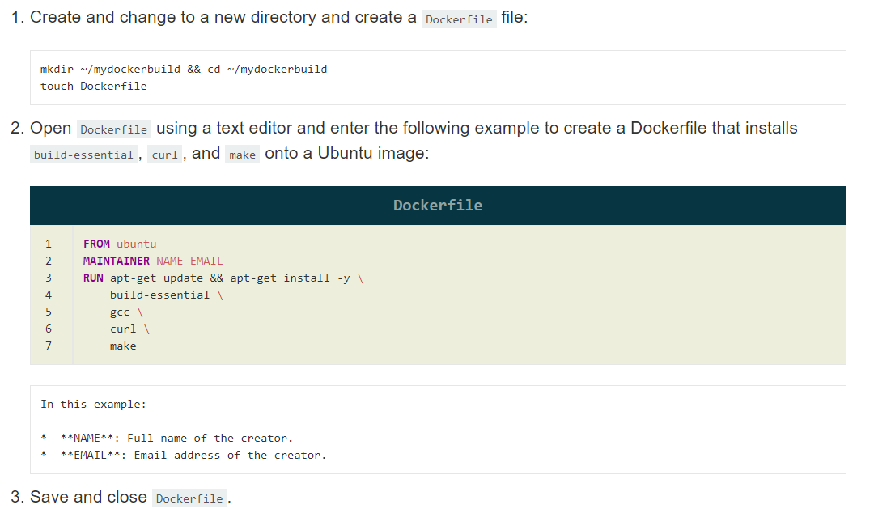

Build a Docker Image from the Dockerfile

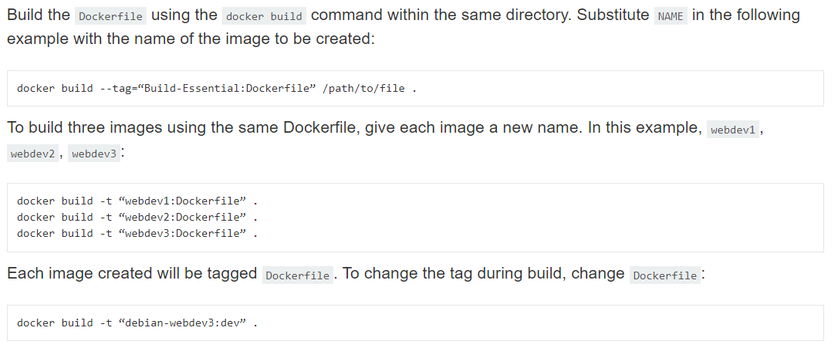

Basic List of Docker Commands
- docker run – Runs a command in a new container
- docker start – Starts one or more stopped containers
- docker stop – Stops one or more running containers
- docker build – Builds an image form a Docker file
- docker pull – Pulls an image or a repository from a registry
- docker push – Pushes an image or a repository to a registry
- docker export – Exports a container’s filesystem as a tar archive
- docker exec – Runs a command in a run-time container
- docker search – Searches the Docker Hub for images
- docker attach – Attaches to a running container
- docker commit – Creates a new image from a container’s changes

Docker Container Commands
- docker create [IMAGE] - Create a container (without starting it)
- docker rename [CONTAINER_NAME] [NEW_CONTAINER_NAME] - Rename an existing container
- docker run [IMAGE] [COMMAND] - Run a command in a new container
- docker run --rm [IMAGE] – removes a container after it exits
- docker run -td [IMAGE] – starts a container and keeps it running
- docker run -it [IMAGE] – starts a container, allocates a pseudo-TTY connected to the container’s stdin, and creates an interactive bash shell in the container
- docker run -it-rm [IMAGE] – creates, starts, and runs a command inside the container Once it executes the command, the container is removed
- docker rm [CONTAINER] - Delete a container (if it is not running)
- docker update [CONTAINER] - Update the configuration of one or more containers

Starting & Stopping Containers Commands
- docker start [CONTAINER] - Start a container
- docker stop [CONTAINER] - Stop a running container
- docker restart [CONTAINER] - Stop a running container and start it up again
- docker pause [CONTAINER] - Pause processes in a running container
- docker unpause [CONTAINER] - Unpause processes in a running container
- docker wait [CONTAINER] - Block a container until others stop (after which it prints their exit codes)
- docker kill [CONTAINER] - Kill a container by sending a SIGKILL to a running container
- docker rm $(docker ps –aq) – Remove all containers
- docker rmi $(docker images –q) – Remove all images
- docker stop $(docker ps –aq) – Stop all running containers
- docker attach [CONTAINER] - Attach local standard input, output, and error streams to a running container

Docker Image Commands
- docker build [URL] - Create an image from a Dockerfile
- docker build -t – Builds an image from a Dockerfile in the current directory and tags the image
- docker pull [IMAGE] - Pull an image from a registry
- docker push [IMAGE] - Push an image to a registry
- docker import [URL/FILE] - Create an image from a tarball
- docker commit [CONTAINER] [NEW_IMAGE_NAME] - Create an image from a container
- docker rmi [IMAGE] - Remove an image
- docker load [TAR_FILE/STDIN_FILE] - Load an image from a tar archive or stdin
- docker save [IMAGE] > [TAR_FILE] - Save an image to a tar archive, streamed to STDOUT with all parent layers, tags, and versions

Docker Commands for Container & Image Information
- docker ps - List of running containers
- docker ps -a – Lists both running containers and ones that have stopped
- docker ps –aq – List all containers (Only ID’s)
- docker logs [CONTAINER] - List the logs from a running container
- docker inspect [OBJECT_NAME/ID] - List low-level information on Docker objects
- docker events [CONTAINER] - List real-time events from a container
- docker port [CONTAINER] - Show port (or specific) mapping for a container
- docker top [CONTAINER] - Show running processes in a container
- docker stats [CONTAINER] - Show live resource usage statistics of containers
- docker diff [CONTAINER] - Show changes to files (or directories) on a filesystem
- docker image ls - List all images that are locally stored with the docker engine
- docker history [IMAGE] - Show the history of an image
- docker image prune – Remove Un-Used Images & Dangling Images
- docker image prune -a – Remove all un-used images
- docker image prune -a --filter “until=12h” – Remove all un-used images using filters
- docker image prune -a --force --filter “until=12h” – Remove all un-used images using filters forcibly.
- docker volume prune – Remove all un-used volumes
- docker system prune – Removes all stopped containers, dangling images, and unused networks.
- docker image -f “dangling=true” -q – Remove all dangling images (Orphan Images or No Relationship Images or Un-used Images)

Docker Commands for Network
- docker network ls - List of networks
- docker network rm [NETWORK] - Remove one or more networks
- docker network inspect [NETWORK] - Show information on one or more networks
- docker network connect [NETWORK] [CONTAINER] - Connects a container to a network
- docker network disconnect [NETWORK] [CONTAINER] - Disconnect a container from a network

